AGILE:
- It is a software development methodology.
- It makes software dev flexible and adaptable.
- Instead of trying to make the whole thing perfect, this methodology focuses to making little by little, testing it and improving it continiously.
- As we keep working on a software, we modify it according to latest requirements and adjust our plans accordingly.
- This methodology focuses on leveraging skillset and expertise of different individuals in a team and to get things done.
- Agile development refers to any development process that is aligned with the concepts of the Agile Manifesto. The Manifesto was developed by a group of fourteen leading figures in the software industry, and reflects their experience of what approaches do and do not work for software development.
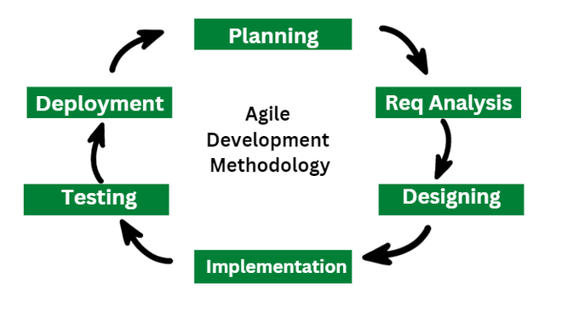

SCRUM
- Scrum is a subset/specific manner of doing AGILE development.
- It is lightweight process framework Contains simple and easy to follow set of rules for teams to work efficiently.
- Scrum needs teams to work in short cycles called SPRINTS.
- Scrum has 3 subcategories: ROLES, ARTIFACTS, TIMEBOXES
- Scrum processes enable organizations to adjust smoothly to rapidly-changing requirements, and produce a product that meets evolving business goals.
  - Increases quality of the deliverables
  - Cope better with sudden changes
  - Provide better estimates that are reliable.
  - Be in control of project schedule and state.

BENEFITS OR SCRUM AGILE DEV PROCESS TO:
- CUSTOMER ->
  - Customer find vendor is more responsive to his requirements.
  - High value features are developed and delivered more quickly within short cycles.

- VENDORS ->
  - Vendors reduce wastage of his resources by focusing on high-value features and reduces time-to-market relative to waterfall process.
  - Improved customer satisfaction leads to better customer retention and more positive future references.

- DEVLOPMENT TEAMS ->
  - Team members enjoy development work as they see their work being used and valued.
  - Team members reduce non-productive work ( ex: writing specifications or other artificats that no one uses).
  - Team members also know their work is valued, because requirements are chosen to maximize value to customers.

- PRODUCT MANAGERS ->
  - Responsible for keeping customers happy by ensuring development work is aligned with customer needs.
  - Scrum makes this possible by providing oppurtunities to re-prioritize work.

- PROJECT MANAGERS ->
  - Filling the role of ScrumMaster; finds that planning and tracking are easier and more concrete.
  - The focus on task-level tracking, keeping check on daily progress all together give the awareness about state of the project.

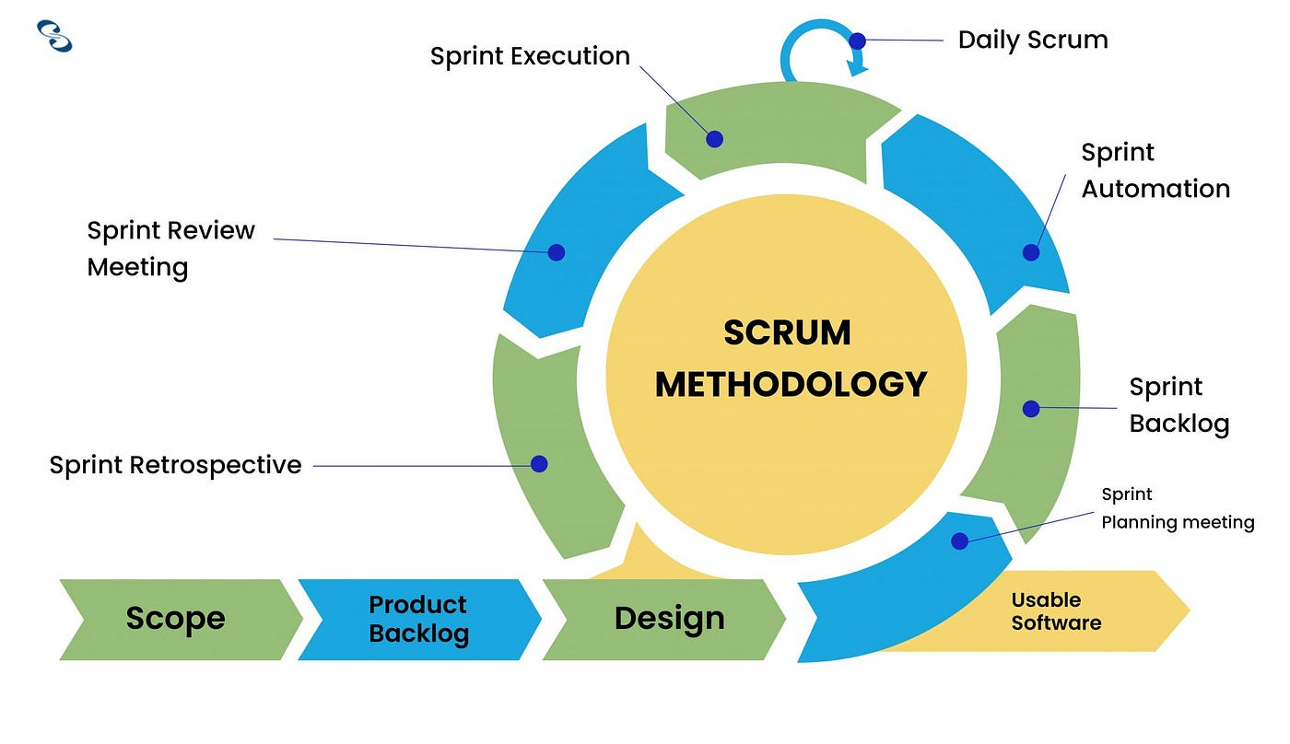

USER STORY:
- It is a simple description of the feature needed from the perspective of end- user. It is a way to capture what the user wants to achieve rather than how to achieve it.
- Format:
  - As a office worker
  - I want to be able to print docs from phone.
  - So that I can save time.

  - As a [type of user]
  - I want [feature]
  - So that [benefit]

- User Story helps teams to understand the user need and prioritize features accordingly.

ROLES:
- SCRUM-MASTER:
  - Facilitates the scrum framework and ensure team follows processes.
  - Removes obstacles from team’s progress.
  - Coaches team on Scrum values and principles.

- PRODUCT OWNER:
  - Maintains product backlog.
  - Ensures features, backlogs are upto date and prioritize what to do.
  - Makes decision on product features and requirements.
  - Acts as a voice of customers.

- TEAM:
  - Cross domain group of developers, testers, designers.
  - Collaborates to complete work items in sprint backlog.
  - Self organising and autonomous.
  - Shares knowledge, skills and expertise to achieve sprint goals.

SCRUM TEAM = SCRUM-MASTER+PRODUCT OWNER+TEAM.

SPRINTS:
- Short, time-boxed period when a scrum team works to complete a set amount of work.
- Sprint last for 2-4 weeks to work on a set of prioritized tasks.
- Key chacteristics:
  - Fixed Duration
  - Clear goals and objectives(Sprint backlog)
  - Dedicated team works on sprint tasks.
  - Daily scrum meetings for progress updates.

SPRINT PLANNING:
- Purpose of sprint planning is to define what can be delivered in the spint and how that work will be achieved.
- Sprint planning is done in collaboration with the whole scrum team.

- WHAT: The product owner describes the goal or the sprint and what backlogs can contribute to that goal. Scrum Team decides what can be done in coming sprint and what they will do during the sprint to make it happen.

- HOW: The development team plans the work necessary to deliver the sprint goal. Ultimately a negotiation between development team and product owner based on value and effort.

- WHO: Product owner, Team.

- INPUTS: The Product backlog, as it may be potentially a part of the current sprint.

- OUTPUTS: The essential output of sprint meeting is that team can describe the goal of the sprint and how it will start working towards that goal.

